Submit to Clerk of the Board with accompanying paperwork (Resolution, Agreements, etc.)

AGENDA SHEET

SUBMITTING DEPARTMENT: Superior Court CONTACT PERSON: Ashley Callan PHONE NUMBER: 509-477-4401

CHECK TYPE OF MEETING ITEM BELOW: BELOW FOR CLERK’S USE ONLY:
2:00 PM CONSENT AGENDA: Clerk’s Resolution No. _______________________
BY LEAVE: Approved: Majority/Unanimous________________ Denied: Majority/Unanimous __________________

5:00 PM LEGISLATIVE SESSION: Renews/Amends No._________________________ BY LEAVE: Public Works No. ___________________________
Purchasing Dept. No.________________________

SPECIAL SESSION:

AGENDA TITLE: IN THE MATTER OF ACCEPTING A CONTRACT BETWEEN WASHINGTON STATE DEPARTMENT OF SOCIAL AND HEALTH SERVICES (DSHS) AND SPOKANE COUNTY FOR COURT COMMISSIONER SERVICES FOR THE PERIOD OF JULY 1, 2016 THROUGH JUNE 30, 2021.

BACKGROUND (Attach separate sheet(s) if necessary): The purpose of this contract is to engage the services of a Court Commissioner to ensure that all Title IV-D child support cases are processed with priority in a manner sufficient to meet all relevant program standards and time frame requirements set for in Title IV-D of the Social Security Act and related provisions of the Code of Federal Regulations including 45 CFR Part 303.

RECOMMENDATION: Approve

FISCAL IMPACT: No funding – Fee for Service

SIGNATURES:

_________________________________ |  | ____________________________________
Department Head/Elected Official or |  | Gerry Gemmill,
Designated Authority (Requesting Agenda Item) |  | Chief Executive Officer
________________________________________ |  | ____________________________________________
Grants Administrator (sign-off) |  | Auditor’s Office
_________________________________ |  | ____________________________________
Treasurer’s Office |  | Budget Office

This item will need to be codified in the Spokane County Code.

NO. __________________

BEFORE THE BOARD OF COUNTY COMMISSIONERS

OF SPOKANE COUNTY, WASHINGTON

IN THE MATTER OF ACCEPTING A CONTRACT )
BETWEEN WASHINGTON STATE DEPARTMENT )
OF SOCIAL AND HEALTH SERVICES (DSHS) AND ) R E S O L U T I O N
SPOKANE COUNTY FOR COURT COMMISSIONER ) SERVICES FOR THE PERIOD OF JULY 1, 2016 )
THROUGH JUNE 30, 2021 )
WHEREAS, pursuant to the provisions of RCW 36.32.120(6), the Board of County Commissioners of Spokane County, Washington (hereinafter sometimes referred to as the “Board”) has the care of County property and the management of County funds and business; and
WHEREAS, Spokane County Superior Court is desirous to contract with Washington State Department of Social and Health Services (DSHS) for Court Commissioner services during the period of July 1, 2016 through June 30, 20121; and
WHEREAS, the purpose of this contract is to engage the services of a Court Commissioner to ensure that all Title IV-D child support cases are processed with priority in a manner sufficient to meet all relevant program standards and time frame requirements set for in Title IV-D of the Social Security Act and related provisions of the Code of Federal Regulations including 45 CFR Part 303; and
WHEREAS, the County has adopted a Grants Management Policy under Resolutions No. 12-1017 and No. 13-0219 (the “Policy”). Based on the Policy, Spokane County Grants Administrator or designee has recommended that the Board of County Commissioners accept the contract between the Department of Social and Health Services (DSHS) and Spokane County for Court Commissioner Services.
NOW, THEREFORE, BE IT HEREBY RESOLVED by the Board of County Commissioners of Spokane County that pursuant to the provisions of the County’s Grants Management Policy adopted under Resolutions No. 12-1017 and No. 13-0219, that:
- the Board does hereby accept a contract from the Department of Social and Health Services (DSHS) and Spokane County for Court Commissioner services for the period of July 1, 2016 through June 30, 2021; and
- either the Chairman of the Board, majority of the Board, Chief Operating Officer, Chief Budget Officer, Chief Executive Officer, or the elected official of the office receiving the contract, is hereby authorized to execute, at other than an open meeting, any and all documents to implement this award as well as any subsequent amendments after review by the Grants Administrator or designee.
PASSED AND ADOPTED this 14th day of June, 2016.
BOARD OF COUNTY COMMISSIONERS
OF SPOKANE, COUNTY, WASHINGTON
 |  | _____________________________________
ATTEST: |  | Shelly O’Quinn, Chair
CLERK OF THE BOARD
 |  | _____________________________________
 |  | Al French, Vice Chair
__________________________
Ginna Vasquez
 |  | _____________________________________
 |  | Nancy McLaughlin, Commissioner
Page 1 of 1

COUNTY DSHS Agreement Number
PROGRAM AGREEMENT 1663-67505
Court Commissioner’s Services

This Program Agreement is by and between the State of Washington Administration or Division Department of Social and Health Services (DSHS) and the County identified Agreement Number below, and is issued in conjunction with a County and DSHS Agreement On County Agreement Number General Terms and Conditions, which is incorporated by reference.

DSHS ADMINISTRATION DSHS DIVISION DSHS INDEX NUMBER DSHS CONTRACT CODE
Economic Services Division of Child Support 1239 3051CS-63
Administration

DSHS CONTACT NAME AND TITLE DSHS CONTACT ADDRESS

Kimberly Curtis PO Box 9162
Contracts Program Manager Olympia, WA Click here to enter text.
DSHS CONTACT TELEPHONE DSHS CONTACT FAX DSHS CONTACT E-MAIL
(360)664-5315 curtiks@dshs.wa.gov

COUNTY NAME COUNTY ADDRESS

Spokane County 1116 W Broadway
Spokane, WA 99260-0175
COUNTY FEDERAL EMPLOYER IDENTIFICATION COUNTY CONTACT NAME NUMBER
Ashley Callan
COUNTY CONTACT TELEPHONE COUNTY CONTACT FAX COUNTY CONTACT E-MAIL
(509) 477-4401 acallan@spokanecounty.org

IS THE COUNTY A SUBRECIPIENT FOR PURPOSES OF THIS PROGRAM CFDA NUMBERS AGREEMENT? 93.563
Yes

PROGRAM AGREEMENT START DATE PROGRAM AGREEMENT END DATE MAXIMUM PROGRAM AGREEMENT AMOUNT
07/01/2016 06/30/2021 Fee For Service
EXHIBITS. When the box below is marked with an X, the following Exhibits are attached and are incorporated into this County Program Agreement by reference:
Exhibits (specify): No Exhibits.
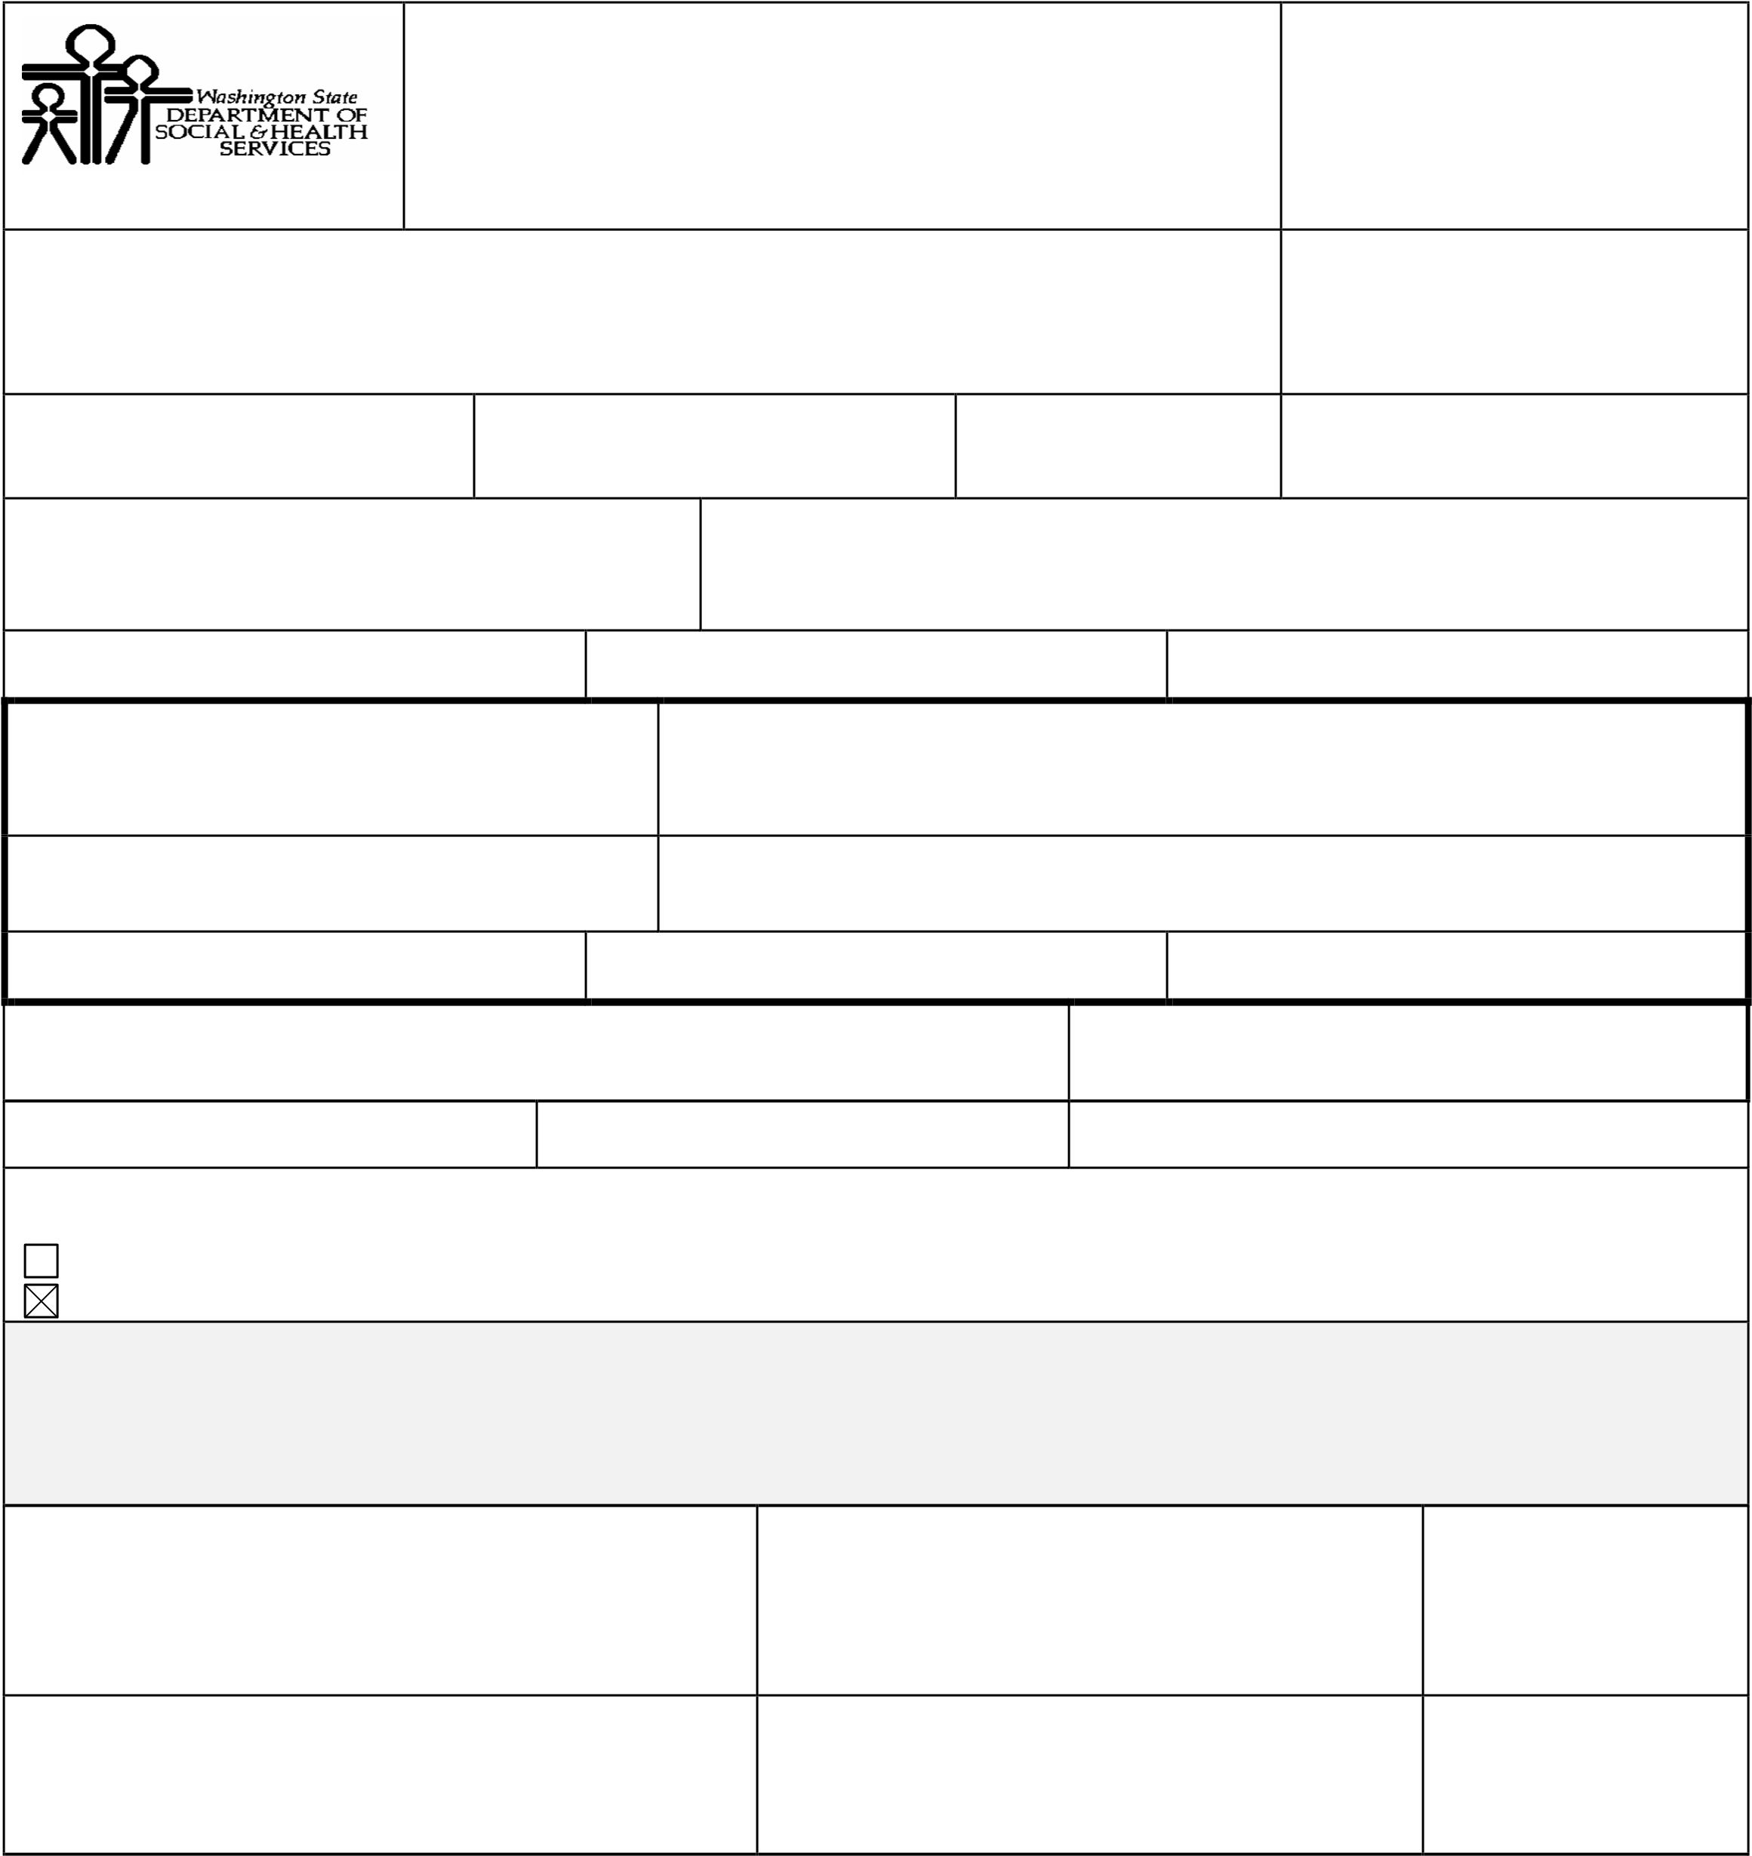
The terms and conditions of this Contract are an integration and representation of the final, entire and exclusive understanding between the parties superseding and merging all previous agreements, writings, and communications, oral or otherwise, regarding the subject matter of this Contract. The parties signing below represent that they have read and understand this Contract, and have the authority to execute this Contract. This Contract shall be binding on DSHS only upon signature by DSHS.

COUNTY SIGNATURE(S) PRINTED NAME(S) AND TITLE(S) DATE(S) SIGNED

The Honorable Salvatore Presiding Judge F. Cozza
Spokane County Superior Court

DSHS SIGNATURE PRINTED NAME AND TITLE DATE SIGNED

Kimberly S. Curtis, Government Liaison/Contracts Manager
DSHS/Division of Child Support

1. Definitions Specific to Special Terms. The words and phrases listed below, as used in this Contract, shall each have the following definitions:
- “Cost Reimbursement Plan” means the DCS approved funding methodology and process by which Title IV-D reimbursement claims are calculated by the County.
- “Court Commissioner” means a person appointed by the County Superior Court to carry out the judicial duties authorized by Revised Code of Washington (RCW) 2.24.040 and Washington Constitution Article IV, Section 23.
- “DCS” means the Division of Child Support, a division of the Department of Social and Health
Services’ Economic Services Administration, the single designated entity which administers, supervises, and monitors Washington State’s child support enforcement program and State Plan under Title IV-D of the Social Security Act.
- “DSHS” means the State of Washington’s Department of Social and Health Services.
- “Dedicated Docket” means a regularly scheduled court calendar devoted to the expedited processing of Title IV-D child support services cases which provides the time required for the volume of Title IV-D cases.
- “Direct Costs” means costs which are incurred by and directly allocable to the County.
- “Expedited Processes” are as defined in 45 CFR Chapter III, Part 303, Section 303.101.
- “Federal Financial Participation” means the percentage of costs that the federal government reimburses DCS for expenses incurred in carrying out the Washington State Title IV-D child support program.
- “Federal Incentive” means the additional reimbursement of funds from the federal government to DCS based upon specific performance measures.
- “Indirect Costs” means costs that are incurred by the County but not directly allocable to the County in carrying out the IV-D child support program.
- “Title IV-D Child Support matters or services” mean and includes: the establishment of paternity; the establishment and modification of child support orders; the enforcement of judicially or administratively ordered child support or medical support obligation in cases initiated by the County Prosecuting Attorney, the Attorney General, or an attorney contracted to act on behalf of the State of Washington. Title IV-D of the Social Security Act is codified at 42 USC Chapter 7, Subchapter IV, Part D, section 651 et seq.

2. Purpose
Engage the services of a Court Commissioner to ensure that all Title IV-D child support cases are processed with priority in a manner sufficient to meet all relevant program standards and time frame requirements, set forth in Title IV-D of the Social Security Act and related provisions of the Code of Federal Regulations, including 45 CFR Part 303.
- DCS is required by federal regulation to perform various judicial proceedings and case actions within prescribed time frames, see 45 CFR 303. Federal regulations also provide for enhanced federal funding for DCS when it performs at a high level through the provision of federal incentive payments (45 CFR 304.12).
- The Counties are valuable partners for maintaining compliance with required federal performance standards and achievements-based federal incentive payments. Crucial areas where Court Commissioners help in meeting federal requirements include:
  - Hearing and deciding Title IV-D paternity and child support matters as expeditiously as possible;
  - Entering child support orders that are in accord with the Washington State Child Support Schedule and the obligor’s reasonable ability to pay; and
  - Establishing obligations for provisions of health insurance coverage for the dependent children.
- The rationale for the reimbursement of Court Commissioner time with Title IV-D funds is the federal requirement that states provide an expedited process for adjudicating and concluding Title IV-D cases.
- Consideration is paid under this agreement in order to ensure that all IV-D child support cases are processed with priority in a manner sufficient to meet all relevant program standards and time frame requirements, set forth in Title IV-D of the Social Security Act and related provisions of the Code of Federal Regulations, including 45 CFR Part 303, as in effect or later amended, and such other regulations as may be adopted.
- The parties, under this Agreement, agree to coordinate activities to expedite the establishment, modification, and enforcement of orders in Title IV-D child support matters.
3. Period of Performance
The period of performance is as stated on Page 1 of this Agreement.

4. Duties of the County
The County is empowered under state law through the use of Court Commissioners to preside over family law judicial proceedings in Superior Court. Under this Agreement, the County shall have the following responsibilities:
- To preside over child support related hearings in Superior Court actions.
- To comply fully with the requirements of:
    - 42 USC Chapter 7, Subchapter IV, Part D, sections 651 et seq. (Title IV-D of the Social Security Act);
    - 45 CFR Chapter III, Part 302, section 302.34 (Cooperative Arrangements); Part 303, section
303.107 (Requirements for Cooperative Arrangements); Part 304 (Federal Financial
Participation); and Part 305 (Program Performance Measures, Standards, Financial Incentives, and Penalties);
(3) 2 CFR Part 200 (Uniform Administrative Requirements, Cost Principles, and Audit Requirements for Federal Awards).
- To ensure that an adequate amount of time is set aside for expedited processing of Title IV-D child support cases initiated by the County Prosecuting Attorney, the Attorney General, or an attorney contracted to act on behalf of the State of Washington. Preferable methods for achieving this goal include dedicated dockets, or set-aside time on family law calendars exclusively for IV-D cases.
- If the County cannot provide a dedicated docket for Title IV-D cases, the County must develop an acceptable alternative process to ensure expedited handling of these cases.
- To meet as needed with the County Prosecuting Attorney and DCS to review the effectiveness of the expedited processes in meeting the program standards and time frame requirement defined in 45 CFR Part 303.
- To provide DCS an annual budget of court costs and expenditures for which reimbursement is expected to be claimed under this Agreement, using a format established by DCS. The County must monitor its budget and reimbursements. If initial budget authorization is found to be insufficient for the full calendar year, the County must submit a budget amendment request prior to the submission of any reimbursement claims that will result in exceeding the approved budget.
- To maintain on file with DCS a current County Indirect Cost Allocation Plan. The Plan, which is the responsibility of the County, must be updated annually in accordance with federal requirements contained in 2 CFR Part 200.
- To maintain or forward to DCS case records and supporting fiscal records as are required by state or federal laws or regulations adopted pursuant to Title IV-D.
- To retain case records for five (5) years after final disposition and be available for inspection, review, or audit by authorized DCS personnel, the Office of the State Auditor or federal auditors during the Agreement period.
- To submit to DCS copies of any support orders, documents or information obtained that indicates the disposition of cases.
- To respond to reasonable requests for information from DCS regarding the current status of cases.
- To respond to reasonable requests for information from DCS regarding performance under the contract.

5. Duties of the Division of Child Support
DCS is the designated single state entity that administers, supervises, and monitors Washington
State’s Child Support Enforcement Program and the State Plan under Title IV-D of the Social Security Act. Under this Agreement, DCS will have the following responsibilities:
- To comply fully with the requirements of:
  - 42 USC Chapter 7, Subchapter IV, Part D, sections 651 et seq. (Title IV-D of the Social Security Act);
  - 45 CFR Chapter III, Part 302, section 302.34 (Cooperative Arrangements); Part 303, section 303.107 (Requirements for Cooperative Arrangements); Part 304 (Federal Financial
Participation); and Part 305 (Program Performance Measures, Standards, Financial Incentives, and Penalties);
  - 2 CFR Part 200 (Uniform Administrative Requirements, Cost Principles, and Audit Requirements for Federal Awards).
- To inform counties of:
  - Relevant federal statutes, regulations and policies;
  - Provisions of the State Plan;
  - State policies, standards, procedures and instructions; and
  - Changes in federal and state funding, match rates, incentives, program requirements, performance measures and reimbursement methodology.
- To provide reasonable technical assistance and cooperation in program and fiscal areas necessary to assist counties in meeting state and federal requirements.
- To reimburse funds expended by the County for allowable expenditures pursuant to an approved reimbursement plan:
  - Reimburse the allowable direct costs of the County in accordance with the County Court Commissioner’s Funding Methodology, at the amount of the current federal match rate.
  - Reimburse the other allowable indirect costs of the County, at the amount of the current federal match rate.
  - Provide a proportionate share of the federal incentive payments to the County.
  - Ensure that reimbursement shall not exceed the estimated financial participation as set forth in the County budget, including subsequent changes, approved by DCS.
  - Ensure compliance with federal regulations at 45 CFR 304.21(b) (Limitations) specifying that federal funding is not available for compensation (salary and fringe benefits), travel and training, and office-related costs incurred by judges or administrative and support staff of judges.
- To send an annual survey to the Court and the County Prosecuting Attorney’s Office to monitor performance under this Agreement.

6. Billing and Payment
a. Billing
- The County shall submit a monthly claim for reimbursement using a format established by DCS and the Cost Reimbursement Plan.
- Monthly claims shall be submitted for reimbursement for the actual allowable expenditures incurred in execution of this Agreement and must be in sufficient detail for DCS, state, and federal auditors to verify consistency.
- All claims for reimbursement must be submitted to DCS within 90 days from the date of expenditure. No claim submitted more than 12 months after the date of expenditure will be reimbursed.
- Any funds paid to the County which is later disallowed by state or federal auditors must be returned to DCS.
- The County shall not claim reimbursement for any funds expended in execution of this
Agreement that are, or have been derived directly from, federal funds, or are to be allocated to, or included as, a cost of any other federally financed program in either the current or a prior period.
- The County shall not claim reimbursement for the acquisition cost of any real property.
- The County shall not claim reimbursement of any personal property having a useful life of more than one year and an acquisition cost of $5,000 or more per unit without prior approval, except for the acquisition of automatic data processing equipment and software. This exception does not apply to imaging and equipment, which must have prior DCS approval due to budget constraints.
- The County may claim reimbursement for the depreciation expense of nonexpendable personal property purchased by the County for use in execution of this Agreement, provided that management and accountability of said property is consistent with federal regulations adopted pursuant to Title IV-D. Per CFR 45.92.32, any equipment or items partially purchased with IV-D funding must be tracked and if disposed of or moved out of the Court’s office, must be accorded a value at the time of disposal and if that value is over $5,000 the asset value must be deducted from that month’s reimbursement claim.
- The County shall not claim reimbursement for charges levied by one county office against another where such fees are not charged uniformly to all those using the provided services. b. Payment
- Monthly claim reimbursements shall be submitted to:
Gail Hurlbert, DCS Fiscal Liaison
DSHS/Division of Child Support
MS 45860
P.O. Box 9162
Olympia, WA 98507-9162

- The County shall contact the Fiscal Liaison, Gail Hurlbert at (360) 664-5237 or by email at hurlbg@dshs.wa.gov concerning billing questions.
- Payment shall be considered timely if made by DSHS within thirty (30) days after receipt of the complete and accurate monthly cost reimbursement claim.
- DSHS may, at its sole discretion, withhold payment claimed by the County for services rendered if the County fails to satisfactorily comply with any term or condition of this Agreement.

